**Adding environment variables**

You can add variables to an active (currently selected) environment by opening the environment from the sidebar and editing it in the tab that opens.

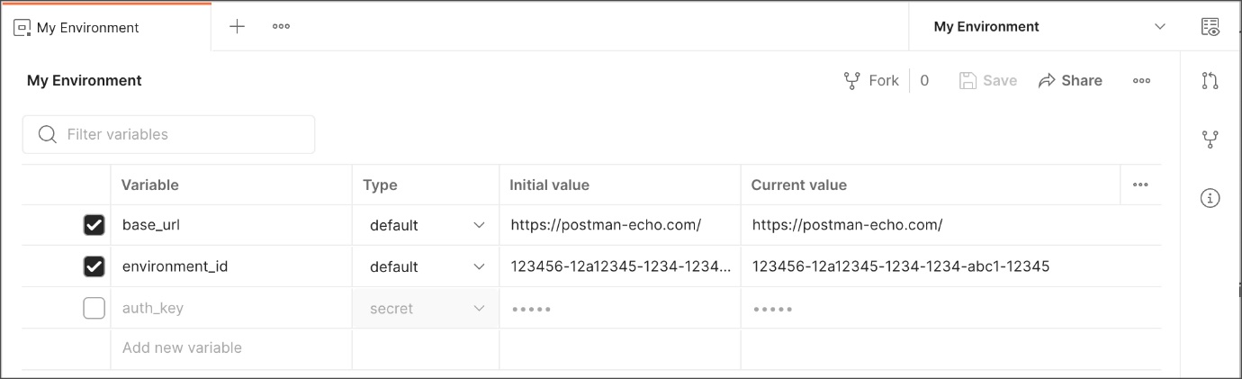

Edit the variable names and values inline, or use the close icon Close icon to delete a variable. Enter the name and values for a new variable on a new line. **Save** when your changes are complete.

Alternatively, select the environment quick look icon Environment quick look icon and edit inline.

If you are working with environment variables as part of a team, you will only be able to change initial values if you have [edit access to the environment](https://learning.postman.com/docs/sending-requests/managing-environments/#managing-environment-roles). You can access all variables in environments shared with you, but may have read-only access to initial values if you have a Viewer role.

Enter a name for your variable, and specify its **Initial** and **Current** values. By default the current value will copy the initial value.

* The **Initial value** is synced to your account using the Postman servers. It's shared with any collaborators who have access to the environment.
* The **Current value** is used in your local instance of Postman, and is never synced to your account or shared with your team *unless you choose to persist it*.

To update the synced variable with your local value, set the initial value to the current value by selecting the more actions icon More actions icon and choosing **Persist**. To reset your local (current) value with the synced value shared with your workspace / collaborators, select **Reset**. You can persist or reset all values in the environment using **Persist All** and **Reset All**.

You can also define environment variables by **Type**. Variables are automatically assigned the default type when created, which is shown as plain text and has no extra properties. You can change sensitive variables to [secret type](https://learning.postman.com/docs/sending-requests/variables/#variable-types), which masks the initial and current values for all workspace members. Secret type can be used to prevent unintentional disclosure of sensitive data, including API secrets, passwords, tokens, and keys.

**Accessing environments**

You can access your environment variables from Postman and from your request elements, including the URL, parameters, body data, and test scripts.

For the list of all your environments, select **Environments** in the sidebar.

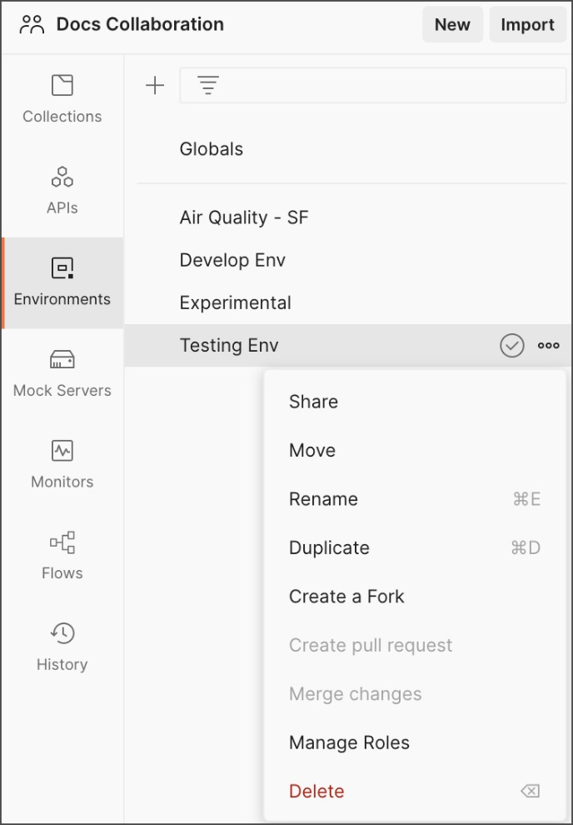

Here you can add, share, duplicate, download, manage access, delete, and remove a shared environment from a workspace. You can also access your global variables by selecting **Globals**.

To view the variables in an environment, select its name. You can edit, add, and remove variables from the environment here. You can also use the **Filter variables** control to search for variables in the environment.



**Selecting an active environment**

To use the variables in an environment, select it from the environment selector at the top right of the workbench.

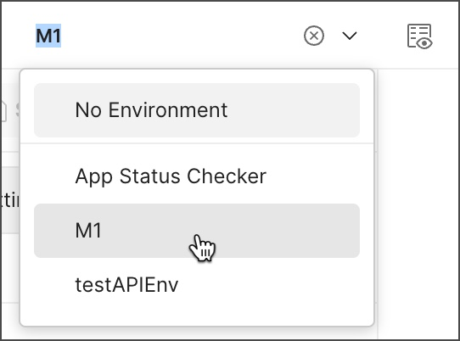

To check a variable value at a glance, use the environment quick look icon Environment quick look icon .

When you choose an environment using the environment selector, Postman treats it as the active environment and runs all requests with values from that environment (if your requests reference environment variables).

To use an environment variable value in a request, reference it by name, surrounded with [double curly braces](https://learning.postman.com/docs/sending-requests/variables/):

{{base_url}}

You can use the same variable notation in request URLs, parameters, headers, and body data.

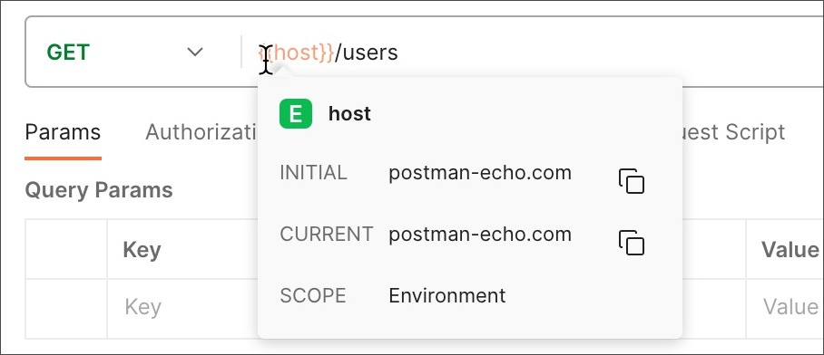

Hover over a variable reference to get its current value.

If more than one variable with the same name is available to a request, Postman will use the value from the variable with narrowest [scope](https://learning.postman.com/docs/sending-requests/variables/#variable-scopes). This means that if you have an environment variable with the same name as a collection or global variable, Postman will use the environment variable, but local and data variable values will supersede environment values. The value of any overridden variables will display with a strikethrough.

You can access current environment variable values in your **Pre-request** and **Tests** code.

pm.environment.get("variable_key");

You can publish environments with your [API documentation](https://learning.postman.com/docs/publishing-your-api/publishing-your-docs/) and the [Run in Postman button](https://learning.postman.com/docs/publishing-your-api/run-in-postman/creating-run-button/).

**Editing environment variables**

You can edit variables either by opening an environment from **Environments** on the left, or by selecting the environment quick look icon Environment quick look icon next to the [environment selector in the workbench](https://learning.postman.com/docs/getting-started/basics/navigating-postman/#environment-selector-and-environment-quick-look) and selecting **Edit**. You can sort the list of variables by selecting any column heading to toggle between alphabetical ascending or descending order and custom order. To sort the list by a custom order, clear the active sort then drag rows to reorder using the handle on the left-hand side.

You will only be able to edit environments where you have [Editor access](https://learning.postman.com/docs/sending-requests/managing-environments/#requesting-environment-access).



Edit the environment name, or the names, [types](https://learning.postman.com/docs/sending-requests/variables/#variable-types), and values of your variables, bearing in mind that **Initial values** will be synced with your Postman account and shared with any collaborators who have access to the environment. Select **Save** when your edits are complete.

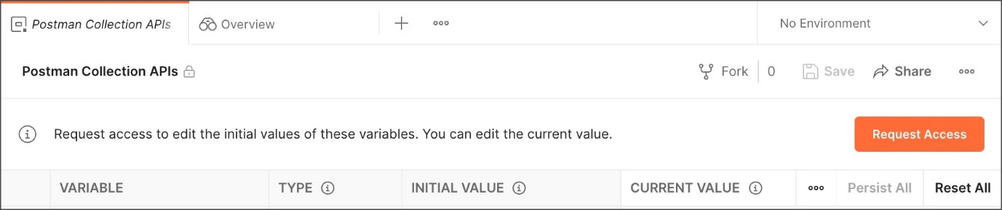

If you have Viewer access to an environment, a lock icon Lock icon next to the name indicates that it's read-only. You will only be able to edit the current value, which is visible only to you and not synced with your Postman account or workspace. To edit initial values you will need to **Request Access**.

You can edit current values for variables in an active (currently selected) environment directly using the environment quick look. Select the edit icon Edit icon to edit your chosen value.

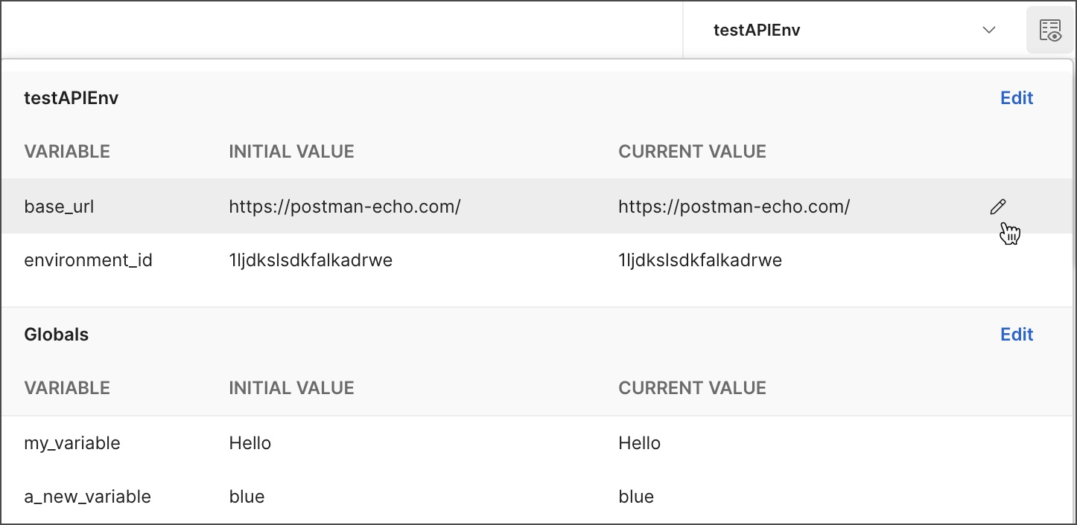

You can also update environment variable values from your test scripts.

**Setting environment variables from scripts**

Your **Pre-request** and **Tests** scripts can update environment variable values.

Use [pm.environment](https://learning.postman.com/docs/writing-scripts/script-references/postman-sandbox-api-reference/) to set an environment variable in the active (currently selected) environment:

pm.environment.set("variable_key", "variable_value");

You can only create new variables from a script in an environment that you have edit access to. If you update or unset a value in a script with Viewer access to the environment, that change will only be visible to you and not shared with your team.

If you use scripts to set environment variable values, these will be reflected for all requests referencing the variables. For example, you can use environments [in conjunction with the collection runner](https://learning.postman.com/docs/collections/running-collections/intro-to-collection-runs/) and [monitors](https://learning.postman.com/docs/monitoring-your-api/intro-monitors/) to share updated values throughout a run for a series of requests as well as after it completes.

**Working with environments as a team**

You can use environments to collaborate on shared resources and configure the visibility of sensitive data, including API secrets, passwords, tokens, and keys.

In a shared workspace, any global variables you create and update will be available to others in the workspace. You can define variables as [secret type](https://learning.postman.com/docs/sending-requests/variables/#variable-types) to mask the initial and current values for all workspace members and prevent unintentional disclosure of sensitive data. You can also use the **Current Value** of global variables to restrict certain values from collaborators, but by default the **Initial value** of a global variable is generally accessible throughout the workspace.

You can move environments to shared workspaces to collaborate with your team.

You must be an Editor on an environment or the Workspace Admin to move an environment to another workspace. To learn more about roles and permissions, see [Defining roles](https://learning.postman.com/docs/collaborating-in-postman/roles-and-permissions/).

In the sidebar, select the environment you want to share, then select the more actions icon More actions icon > **Move**.

Use the search bar to find the workspace you want to move the environment to, or filter by workspace visibility by selecting the filter icon Filter icon .

You can share environments to personal, private, team, and public workspaces that you have access to. Shared private, team, and public workspaces allow you to collaborate with others.

You can't move environments from team, private, or public workspaces to a personal workspace.

Refer to [Roles and permissions](https://learning.postman.com/docs/collaborating-in-postman/roles-and-permissions/) for information on workspace access control within your team.

Select the workspace, then **Move Environment**.

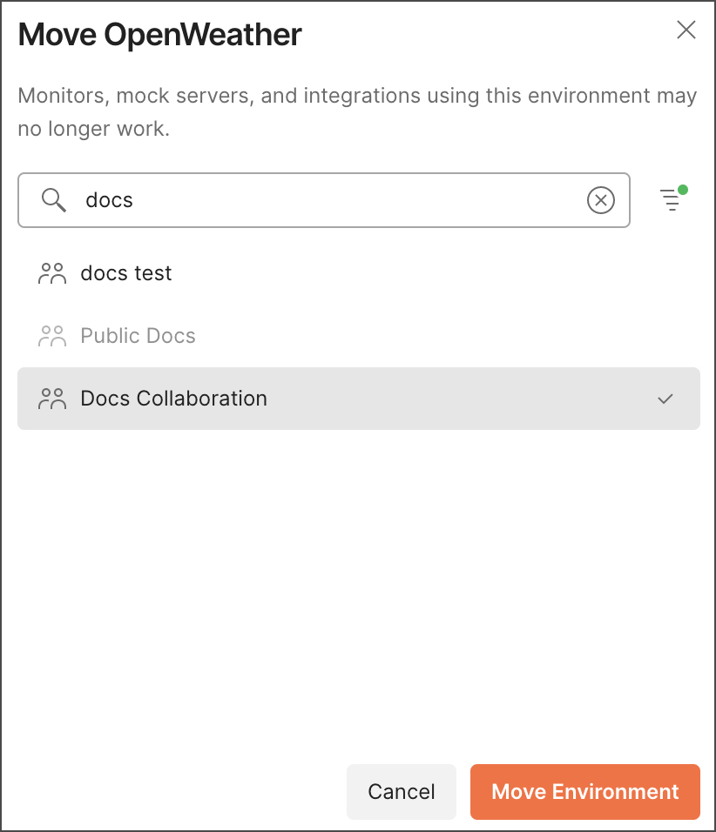

Note that monitors, mock servers, and integrations in the original workspace that are using the environment may no longer work and will need to be re-configured in the new workspace. Collections and APIs that use the environment must be [moved separately](https://learning.postman.com/docs/collaborating-in-postman/working-with-your-team/collaborating-in-team-workspaces/#moving-elements-to-team-workspaces).

You can manage roles on an environment by navigating to it in the sidebar, selecting it, then selecting the more actions icon More actions icon > **Manage Roles**.

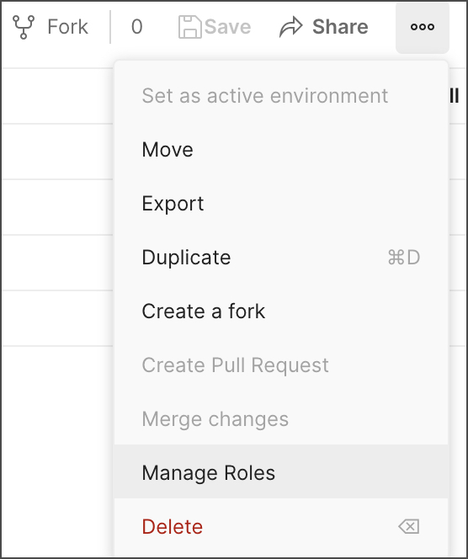

You can also remove a shared environment from a workspace by selecting the more actions icon More actions icon next to the environment name and choosing **Move** to move it to a different workspace or **Delete** to delete it entirely.

To export an environment, select it and select the more actions icon More actions icon in the upper right > **Export**.

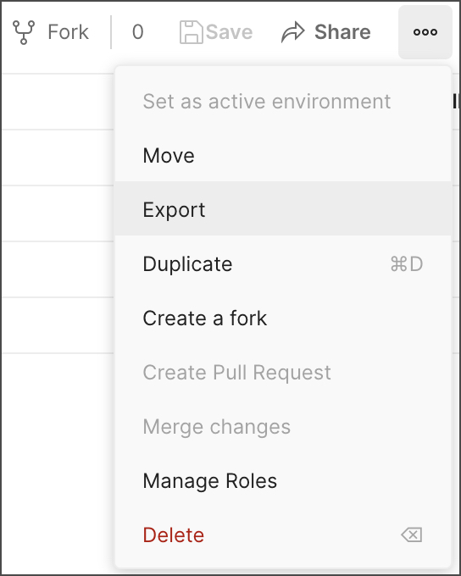

**Managing environment roles**

You can manage roles on an environment by selecting the more actions icon More actions icon in the upper right > **Manage Roles**.

You can assign collaborators the Editor or Viewer role. Team members with the Viewer role can only edit the current values of variables, but they can use the environment when sending requests. If a user requires edit access, they can request it when viewing the environment in the editor.

For more details, see [Environment roles](https://learning.postman.com/docs/collaborating-in-postman/roles-and-permissions/#environment-roles).

**Using an environment in Viewer role**

If you have the Viewer role for an environment, you will be able to access the value of the variables to use them in your requests, but won't be able to update the **Initial value**, which is shared with your team. You can update the **Current value**, but this isn't shared with anyone on your team or synced with your Postman account.

If you are using sensitive data like API credentials, it's safer to use the current value of an environment variable for these. You won't be able to **Persist** the current values to update the initial values of environment variables without edit access to the environment. You can use the **Reset** option to update your local current values with the shared initial value at any time.

**Requesting environment access**

If you need to update the initial value of a variable in an environment you have read-only access to, you can request edit access. Open the environment from **Environments** in the sidebar and select **Request Access**.



Select the team member you want to submit the request to, and select the **Editor** role. Select **Request Access**. You will receive an email when your request is approved.

**Using an environment in Editor role**

If you have edit access to an environment, you can update the variable values from Postman and from your scripts. If you are using sensitive data such as API secrets, passwords, tokens, or keys, you can define variables as [secret type](https://learning.postman.com/docs/sending-requests/variables/#variable-types) to mask their initial and current values. You can also opt to only use current values, which aren't synced or shared with your team.

When you edit the initial value of a shared environment variable, your updated value will be reflected for everyone who has access to the environment, so ensure that you only do this when you are happy for your value to be synced with the Postman servers.

If you clear the checkbox for a variable in your environment, it will only be available to collaborators who also have Editor access to the environment. The variable's listing will also indicate whether it's active. Anyone with the Viewer role for the environment won't be able to access the cleared variable.

With the Editor role, you can [configure access for other team members](https://learning.postman.com/docs/sending-requests/managing-environments/#managing-environment-roles). If you need to specify access but don't have the Editor role, you can [request access](https://learning.postman.com/docs/sending-requests/managing-environments/#requesting-environment-access).

**Forking environments**

You can fork environments to change them without impacting their base versions, or to contribute to their development without having Editor access.

1. Hover over the environment in the sidebar and select the more actions icon More actions icon .
2. Select **Create a Fork**.

You can also fork an environment by selecting **Fork** Fork icon in the environment overview tab.

You can edit your environment fork and use it as needed, or you can [create a pull request](https://learning.postman.com/docs/collaborating-in-postman/using-version-control/creating-pull-requests/) to update the original environment.

**Viewing pull requests, forks, and environment details**

You can view all pull requests, forks, and details about an environment from the right sidebar.

* To view pull requests, select the pull request icon Pull request icon
* To view forks, select the fork icon Fork icon
* To view additional information about the environment, including its ID, creator, and any mock servers or monitors that use it, select the information icon Information icon

If you have [Editor access](https://learning.postman.com/docs/collaborating-in-postman/roles-and-permissions/#environment-roles) on the environment, you can [review pull requests](https://learning.postman.com/docs/collaborating-in-postman/using-version-control/reviewing-pull-requests/#reviewing-pull-requests) and [merge changes into the parent environment](https://learning.postman.com/docs/collaborating-in-postman/using-version-control/forking-elements/#merging-changes-from-a-fork).